
THE SUPERIOR UNIVERSITY LAHORE
GROUP BASED PROJECT
Project Title:
BANK NETWORK DESIGN
Submitted By:
Aima Eirj (063)
Ayesha Noor (034)
Course:
Computer Networks
Submitted To:
Mam Yusra

TABLE OF CONTENTS
- Introduction
- Project Objectives
- Tools & Technologies Used
- Network Topology Design
- IP Addressing & VLAN Plan
- Device Configuration
- Network Security Implementation
- Testing & Verification
- Results
- Conclusions

1. INTRODUCTION
This project presents the design and implementation of a secure and scalable bank network system. The network is divided into multiple departments using VLANs to improve performance and security. A Layer 3 switch is used to perform Inter-VLAN routing, allowing communication between different departments.
DHCP is configured to automatically assign IP addresses to all devices, while DNS is used to provide easy access to an internal bank website using a domain name. Security features such as Port Security and Access Control Lists (ACLs) are implemented to protect sensitive data.
The entire network is designed and tested using Cisco Packet Tracer.

2. PROJECT OBJECTIVES
- To design a scalable bank network
- To implement VLANs for department separation
- To configure Inter-VLAN routing using Layer 3 switch
- To implement DHCP for automatic IP assignment
- To configure DNS for internal website access
- To apply security using Port Security and ACLs
- To test and verify network connectivity

3. TOOLS & TECHNOLOGIES USED
Component | Details
Simulator | Cisco Packet Tracer
Core Device | 3560 Multilayer Switch
Access Devices | 2 × 2960 Switches
End Devices | 12 PCs, 1 Server
Technologies | VLAN, Trunking, Inter-VLAN Routing, DHCP, DNS, ACL, Port Security

4. NETWORK TOPOLOGY DESIGN
A two-layer hierarchical model is used:
- Core Layer → Layer 3 Switch (3560)
- Access Layer → 2960 Switches
All PCs connect to access switches, which connect to the core switch using trunk links. The server is connected to the core switch.
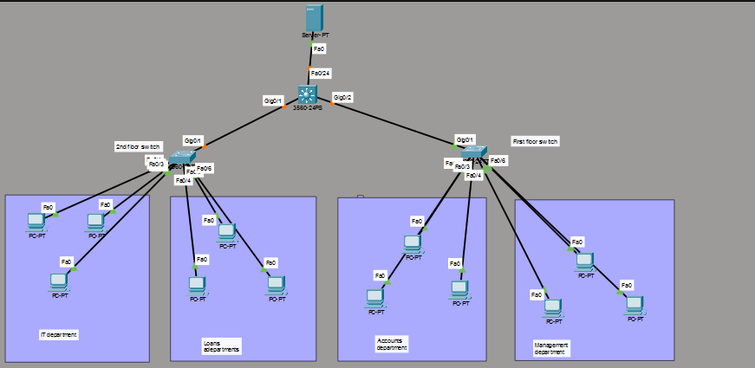

5. IP ADDRESSING & VLAN PLAN
VLAN ID | VLAN Name | Network | Gateway | Department
10 | Management | 192.168.10.0/24 | 192.168.10.1 | Management
20 | Accounts | 192.168.20.0/24 | 192.168.20.1 | Accounts
30
 | Loans | 192.168.30.0/24 | 192.168.30.1 | Loans
40 | IT | 192.168.40.0/24 | 192.168.40.1 | IT
50 | Servers | 192.168.50.0/24 | 192.168.50.1 | Server

6. DEVICE CONFIGURATION

6.1 VLAN & Trunk Configuration
VLANs are created on the Layer 3 switch. Access ports are assigned to VLANs on 2960 switches. Trunk links are used between switches.

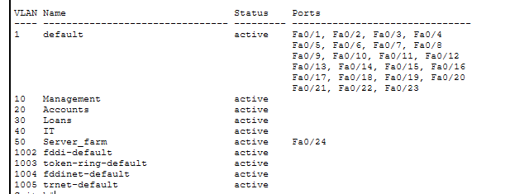

6.2 Inter-VLAN Routing
Routing is enabled using SVI interfaces on the Layer 3 switch.
Example:
ip routing
interface vlan 10
ip address 192.168.10.1 255.255.255.0
no shutdown

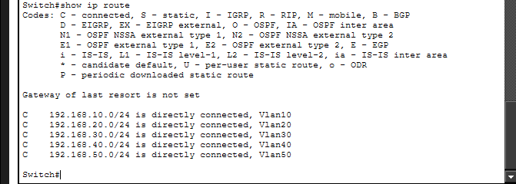

6.3 DHCP Configuration
A DHCP server is configured to automatically assign IP addresses.
Each VLAN has a separate pool:
- VLAN 10 → 192.168.10.0
- VLAN 20 → 192.168.20.0
- VLAN 30 → 192.168.30.0
- VLAN 40 → 192.168.40.0
Default gateway and DNS are also assigned automatically.
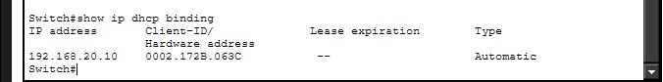

6.4 DNS & Web Server
DNS is configured to map:
bank.local → 192.168.50.2
Users can access the internal website using this domain name. A simple HTML page is created for testing.
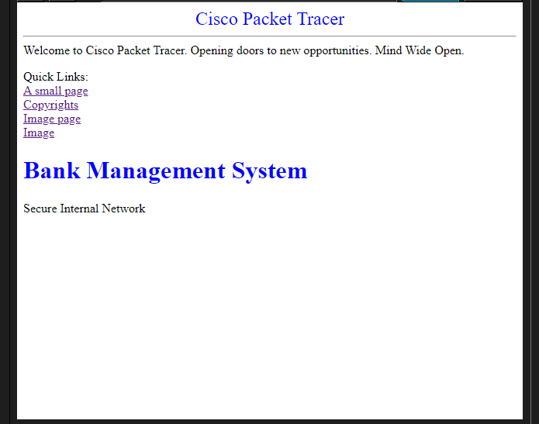

7. NETWORK SECURITY IMPLEMENTATION

7.1 Port Security
Port security is applied to restrict unauthorized devices.

7.2 Access Control List (ACL)
ACL is used to restrict access:
- Accounts and Loans cannot access Server VLAN
- Management and IT are allowed


8. TESTING & VERIFICATION
- PCs receive IP automatically (DHCP)
- Devices in different VLANs can communicate
- Website opens using domain name
- ACL restrictions work correctly
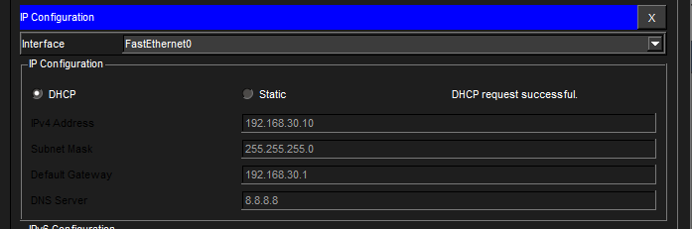

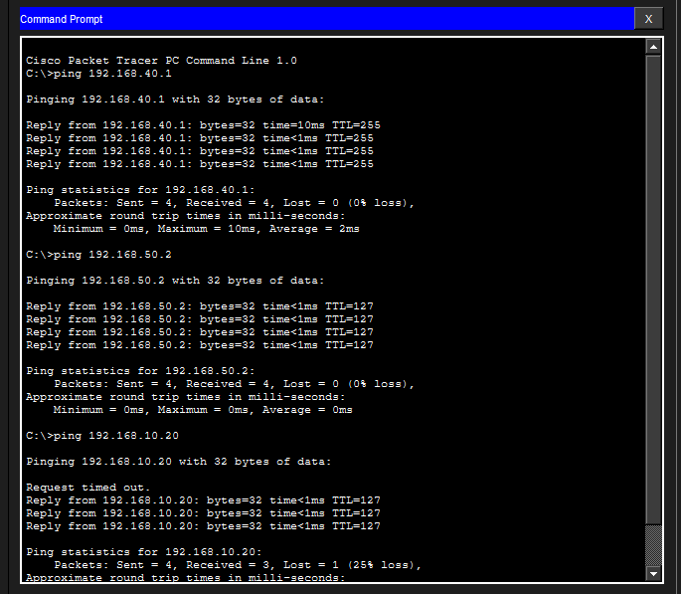

9. RESULTS
The network works successfully with proper segmentation, routing, and security. All objectives are achieved.

10. CONCLUSION
This project demonstrates a complete enterprise-level bank network design. VLANs improve security and performance, while Inter-VLAN routing enables communication. DHCP and DNS simplify network management. Security features ensure protection of sensitive data.
The network is scalable and can be extended for larger organizations.

